NORMALIZATION SOLUTION
Joe's Video Store
View 1 (Customer Rents Video) · View 2 (Video Information) · Merged Model
Instructor answer key — complete 0NF through 3NF for both views, plus the merged 3NF model.

View 1 — Customer Rents Video

0NF — Initial Table

Transaction(TransactionID, TransactionDate, CustomerID, Name, Phone, Address, (VideoID, CopyNumber, Title, ReturnDate, RentalCharge, HistoricalRentalCharge), SubTotal, GST, Total)

1NF

Table 1: Transaction
Transaction(TransactionID, TransactionDate, CustomerID, FirstName, LastName, Phone, Address, City, Prov, PC, SubTotal, GST, Total)

Table 2: TransactionDetail
TransactionDetail(VideoID, CopyNumber, TransactionID (FK), Title, ReturnDate, RentalCharge, HistoricalRentalCharge)
Primary key: VideoID + CopyNumber + TransactionID

Composite attributes (Name → FirstName/LastName; Address → Street/City/Prov/PC) are split, and the repeating video group is moved to a new TransactionDetail table, carrying TransactionID forward as a foreign key.

2NF

Table 1: Transaction — unchanged (single-attribute PK, no 2NF violation possible)
Transaction(TransactionID, TransactionDate, CustomerID, FirstName, LastName, Phone, Address, City, Prov, PC, SubTotal, GST, Total)

Table 2: TransactionDetail
TransactionDetail(VideoID (FK), CopyNumber, TransactionID (FK), ReturnDate, HistoricalRentalCharge)

Table 3: Video (new)
Video(VideoID, Title, RentalCharge)

Title and RentalCharge depend only on VideoID, not on the whole composite key (VideoID + CopyNumber + TransactionID) — a partial dependency. They move to a new Video table. RentalCharge here is the current rate; HistoricalRentalCharge stays in TransactionDetail because it records the rate at the time of that specific rental.

3NF

Table 1: Transaction
Transaction(TransactionID, TransactionDate, SubTotal, GST, Total, CustomerID (FK))

Table 2: Customer (new)
Customer(CustomerID, FirstName, LastName, Phone, Address, City, Prov, PC)

Table 3: TransactionDetail — unchanged (no additional violation)
TransactionDetail(VideoID (FK), CopyNumber, TransactionID (FK), ReturnDate, HistoricalRentalCharge)

Table 4: Video — unchanged
Video(VideoID, Title, RentalCharge)

CustomerID is a non-key attribute in Transaction, and the customer details (name, phone, address) all depend on CustomerID rather than on TransactionID — a transitive dependency. They move to a new Customer table; CustomerID stays in Transaction as a foreign key.

View 1 — 3NF ERD
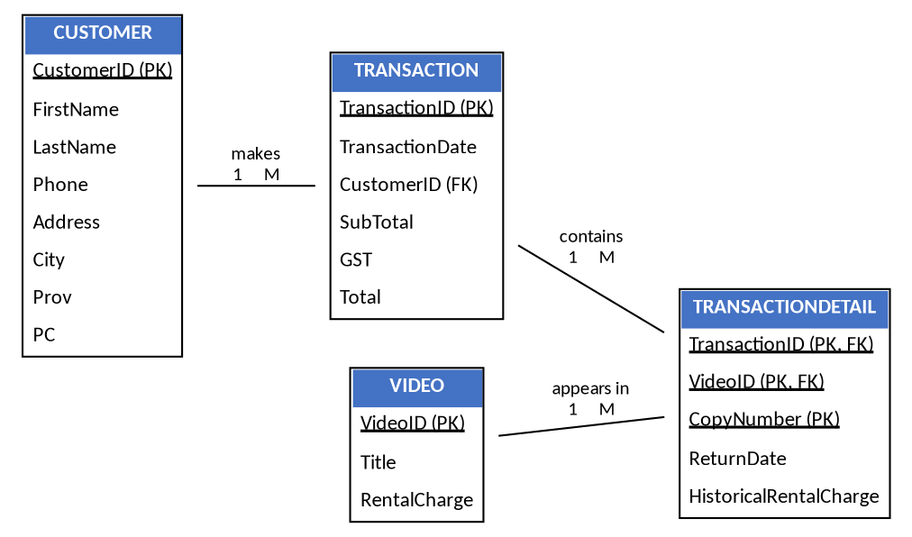

View 2 — Video Information

0NF — Initial Table

Video(VideoID, Title, TypeID, TypeName, NumberOfCopies, NumberOfAvailableCopies, Format, RentalCharge, Cost, RatingCode, RatingDescription, (CopyNumber, AvailableForRental))

1NF

Table 1: Video
Video(VideoID, Title, TypeID, TypeName, NumberOfCopies, NumberOfAvailableCopies, Format, RentalCharge, Cost, RatingCode, RatingDescription)

Table 2: VideoCopy
VideoCopy(VideoID (FK), CopyNumber, AvailableForRental)

2NF — No Violation

Video has a single-attribute PK, so no violation is possible there. VideoCopy's only non-key attribute, AvailableForRental, depends on the whole key (VideoID + CopyNumber) — a specific copy of a specific video. Both tables carry forward unchanged.
Table 1: Video
Video(VideoID, Title, TypeID, TypeName, NumberOfCopies, NumberOfAvailableCopies, Format, RentalCharge, Cost, RatingCode, RatingDescription)

Table 2: VideoCopy
VideoCopy(VideoID (FK), CopyNumber, AvailableForRental)

3NF

Table 1: Video
Video(VideoID, Title, TypeID (FK), NumberOfCopies, NumberOfAvailableCopies, FormatID (FK), RentalCharge, Cost, RatingCode (FK))

Table 2: VideoType (new)
VideoType(TypeID, TypeName)

Table 3: Rating (new)
Rating(RatingCode, RatingDescription)

Table 4: Format (new)
Format(FormatID, FormatDescription)

Table 5: VideoCopy — unchanged
VideoCopy(VideoID (FK), CopyNumber, AvailableForRental)

TypeName depends on TypeID, and RatingDescription depends on RatingCode — both transitive dependencies, so each moves to its own table. Format is a predefined list too (VHS, VCD, DVD), but the source view has no ID for it — only a description. A technical key, FormatID, is added so Format can be normalized the same way as Type and Rating. This is a documented assumption, not something given on the source view.

View 2 — 3NF ERD
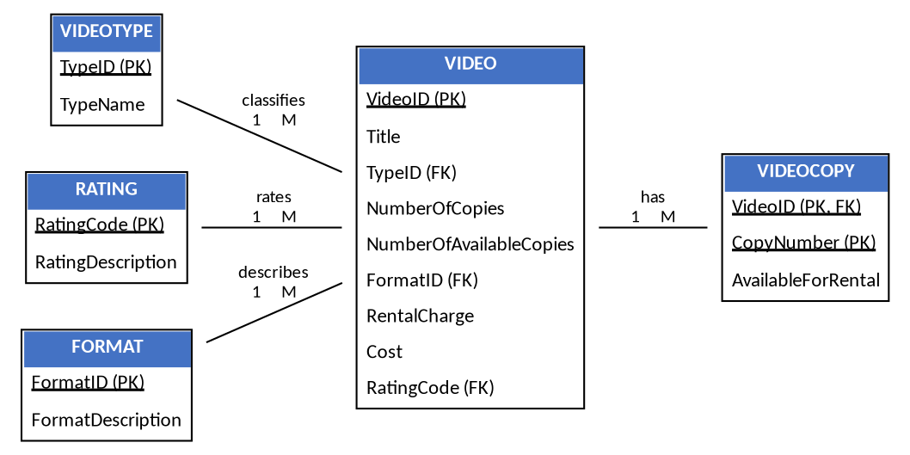

Merging View 1 and View 2

View 1 produced a Video table with VideoID, Title, and RentalCharge. View 2 produced a fuller Video table — VideoID, Title, TypeID (FK), NumberOfCopies, NumberOfAvailableCopies, FormatID (FK), RentalCharge, Cost, RatingCode (FK). Both tables have the same primary key, VideoID, and represent the same real-world entity, so they are merged into a single Video table.
Rule: two tables merge into one when they share the same primary key and describe the same entity. Every attribute from View 1's Video table (Title, RentalCharge) already appears in View 2's Video table, so the merged table is simply View 2's Video table. TransactionDetail keeps a single VideoID (FK) pointing to this merged table.

Merged 3NF Table List
Customer
Customer(CustomerID, FirstName, LastName, Phone, Address, City, Prov, PC)

Transaction
Transaction(TransactionID, TransactionDate, SubTotal, GST, Total, CustomerID (FK))

TransactionDetail
TransactionDetail(TransactionID (FK), VideoID (FK), CopyNumber, ReturnDate, HistoricalRentalCharge)

Video (merged)
Video(VideoID, Title, TypeID (FK), NumberOfCopies, NumberOfAvailableCopies, FormatID (FK), RentalCharge, Cost, RatingCode (FK))

VideoType
VideoType(TypeID, TypeName)

Format
Format(FormatID, FormatDescription)

Rating
Rating(RatingCode, RatingDescription)

VideoCopy
VideoCopy(VideoID (FK), CopyNumber, AvailableForRental)

Final Merged ERD
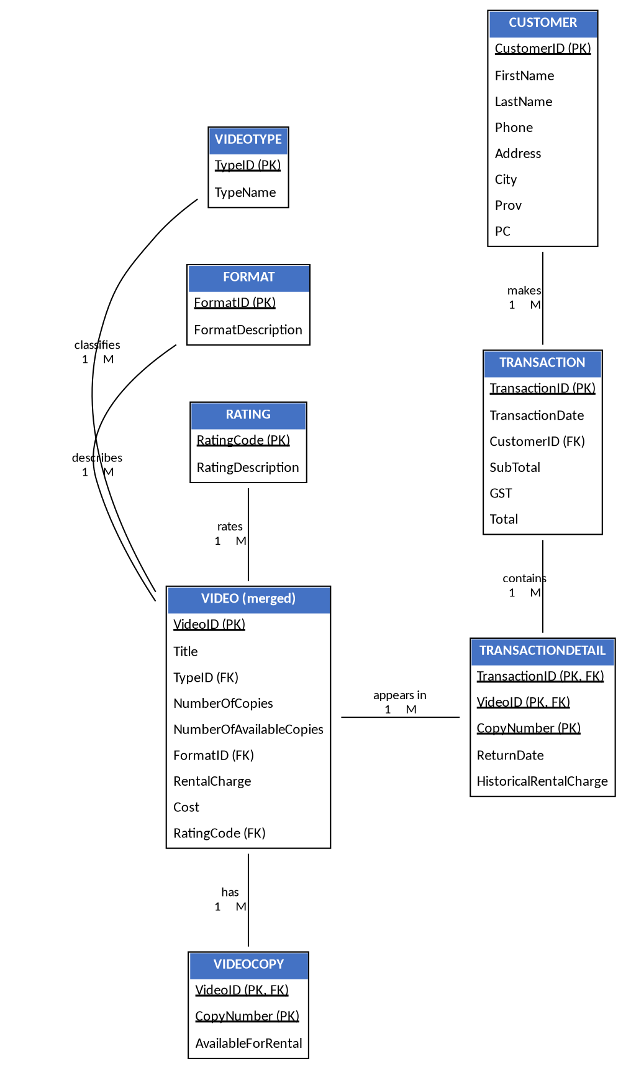

Relationships
Entity A | Relationship | Entity B | Type
Customer | makes | Transaction | 1:M
Transaction | contains | TransactionDetail | 1:M
Video | appears in | TransactionDetail | 1:M
VideoType | classifies | Video | 1:M
Rating | rates | Video | 1:M
Format | describes | Video | 1:M
Video | has | VideoCopy | 1:M

